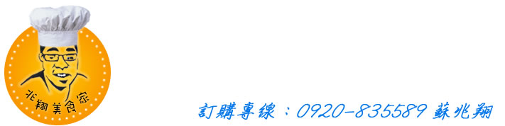

|  |  |  |  |  |  |  |  |
| --- | --- | --- | --- | --- | --- | --- | --- |
| No. | 品名 | 數量/斤 | 金額 | No. | 品名 | 數量/斤 | 金額 |
| 1 | 蜜汁小魚干 | 1斤 | 300 | 16 | 蜜汁黑豆干 | 1斤 | 250 |
| 2 | 黑胡椒毛豆 | 1斤 | 100 | 17 | 柚香蓮藕 | 1斤 | 180 |
| 3 | 涼拌豬耳絲 | 1斤 | 180 | 18 | 香蒜風螺 | 1斤 | 350 |
| 4 | 涼拌海哲絲 | 1斤 | 300 | 19 | 五香豆干 | 1斤 | 100 |
| 5 | 涼拌海帶根 | 1斤 | 100 | 20 | 素什錦 | 1斤 | 100 |
| 6 | 涼拌小黃瓜 | 1斤 | 100 | 21 | 鹹蜆 | 1斤 | 100 |
| 7 | 涼拌鴨掌 | 1斤 | 180 | 22 | 醉蝦 | 1斤 | 550 |
| 8 | 涼拌川耳 | 1斤 | 180 | 23 | 韓式泡菜 | 1罐 | 250 |
| 9 | 涼拌干絲 | 1斤 | 100 | 24 | 黃金泡菜 | 1罐 | 300 |
| 10 | 海味干貝唇 | 1斤 | 180 | 25 | 辣味魚干 | 1斤 | 300 |
| 11 | 蒜香生腸 | 1斤 | 200 | 26 | 涼拌豬干 | 1斤 | 180 |
| 12 | 脆皮豬腳 | 1斤 | 180 | 27 | 香辣牛肚 | 1斤 | 時價 |
| 13 | 麻油腰子 | 1斤 | 450 | 28 |  |  |  |
| 14 | 無骨雞腳(原味) | 1斤 | 260 | 29 |  |  |  |
| 15 | 無骨雞腳(辣味) | 1斤 | 260 | 30 |  |  |  |